Submitting Agreements for Final Contract Execution

Finding Town Templates
Visit the following page on The Hive: https://thehive-beta.townofchapelhill.org/services/bmd/purchasing/
Please Note: The Town Contract templates for DocuSign must be used. They can only be found in the above location of The Hive. Please do not use any previous version of the Town templates.

Contract Process (high-level)
Step 1: Download the template from The Hive
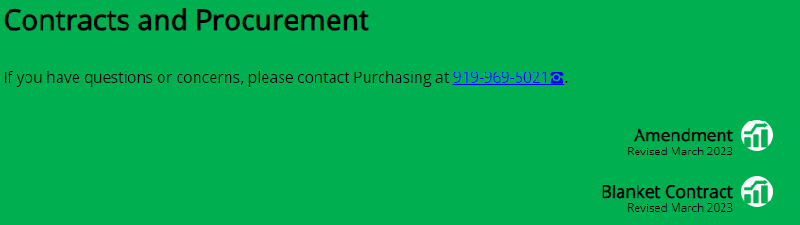
Step 2: Contract Creation
Step 3: Contract Review (PDF with comments), if necessary.
Step 4. Initiate Contract Execution – Complete Form Submission
Once you have finished your reviews from various departments and vendor, it is time to submit the agreement for review.
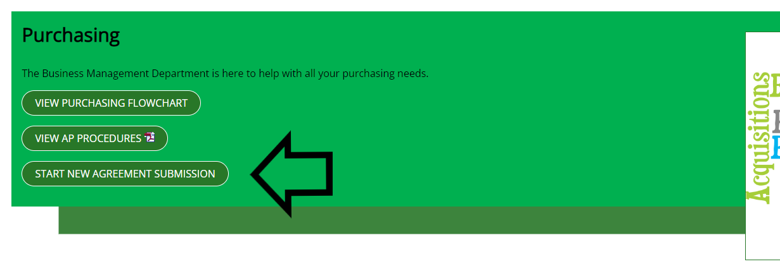
Select “Agreement Submission Form” to get started.

Complete and submit form:
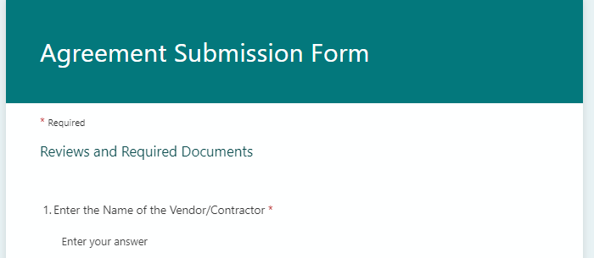

Successful Submission
You will receive the following message after the form has been submitted:

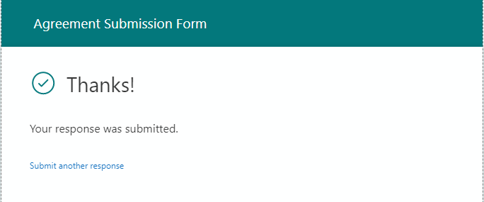

Please note: If the submission does not include the appropriate attachments or information is missing, you may be contacted directly from purchasing.

Final Contract
Once the contract has been executed, Purchasing will add the final copy to Munis.
You will receive a similar message via email with the final executed contract attached:

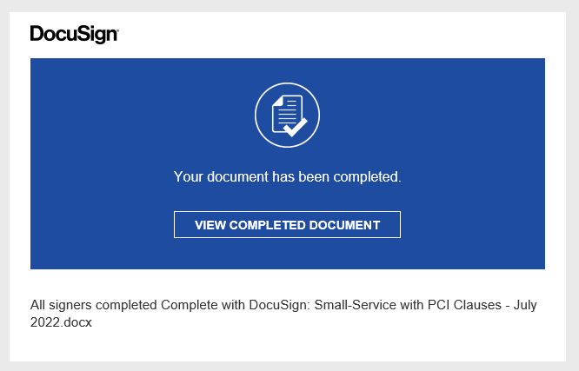

Your email will contain the name of the file.

